OpenCpn : NMEA Input/Output/Multiplexing

<https://opencpn.org/wiki/dokuwiki/doku.php?id=opencpn:supplementary_software:nmea_instruments>

### Nmea Server using Python Script & Launcher_pi

Contributed by Transmitter Dan, reported by R. Gleason

### From the Command Line - Once everything is set up:

from command prompt cd C:/python27  
Command: > python VDRServer1.py Hakefjord-Sweden.txt 127.0.0.1 2947 .033  
Command: > python VDRServer1.py Hartmut-Netherlands.txt 127.0.0.1 2947 .033  
  
Another way to start the Nmea server is to define all the paths to the various files so you don't have to change directory to C:\python\. This example has the Nmea files under C:\Data-Dart\Nmea\ for example:  
Command: > c:\python27\python c:\python27\VDRServer1.py C:\Data-Dart\Nmea\Hakefjord-Sweden.txt 127.0.0.1 2947 .033  
Command: > c:\python27\python c:\python27\VDRServer1.py C:\Data-Dart\Nmea\Hartmut-Netherlands.txt 127.0.0.1 2947 .033

### Download Attached Files

Nmea-Server-Python-Script-README.txt  
VDRServer1.py  
Hakefjord.txt  
Hartmut-Netherlands.txt  
These are available at  
<https://github.com/transmitterdan/VDRplayer>  
[Opencpn Beta File Thingie](https://tgp-architects.com/files/) (Please login with username=rguser, password=rgpass)  
Download from the Nmea-Server folder. PLEASE Remove “.TXT” from VDRServer1.py.TXT

### Install and Setup:

1. Download and install Python27 Python is a platform independent scripting language interpreter.  
2. You can Download Python for Windows here: [https://www.python.org/downloads/](https://www.python.org/downloads/%C2%A0) “Download Python 2.7.10   
3. Execute the python-2-7-10.msi file and install to c:\python27 by default, it will require 95 mb.  
4. Copy the file “VDRServer1.py” file into c:\python27  
5. Copy the NMEA file Hakefjord-Sweden.txt into into c:\python27  
6. Copy the NMEA file Harmut-Netherlands.txt into c:\python27  
7. Open a command prompt Start > Run > enter CMD at the prompt type “CD C:\python27”  
8. Then enter either command:  
Command: python VDRServer1.py Hakefjord-Sweden.txt 127.0.0.1 2947 .033  
Command: python VDRServer1.py Harmut-Netherlands.txt 127.0.0.1 2947 .033  
9. Leave the command prompt window open to keep the Pyton Server program running.  
10. In Opencpn, set up a communications channel for network UDP. This is what the setup screen in O looks like for Windows: In Opencpn Options > Connections > Add connection

Connection Type: Network\\

Protocol: UDP\\

Address: 127.0.0.1\\

Dataport: 2947\\

Priority: 1\\

Control Checksum checked\\

Receive Input checked\\

Output on this port not checked\\

Input Filtering: Sentences only button\\

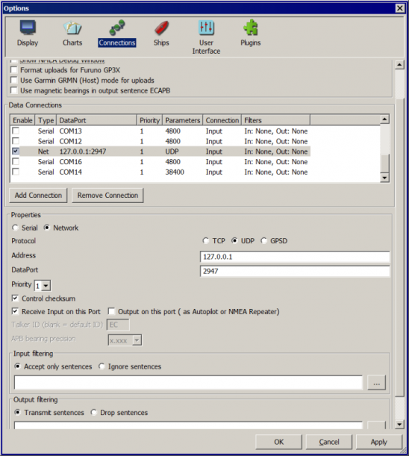  
11. Now you should see the Nmea data being run in Sweden or Netherlands  
12. See TransmitterDan's Python script “VDRServer1.py”, which is also below.

### Using Launcher_pi to make it easy

If you want to make this even easier, you can download the Launcher_pi plugin and install it. Then under Options > Plugins > Launcher, Enable the plugin.  
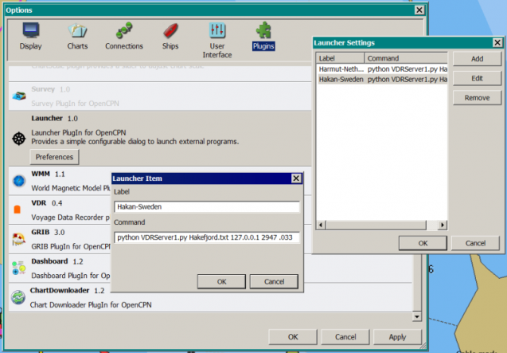  
  
Then use Launcher > Preferences to make appropriate entries to run various nmea files for testing, eg:

Name : Haken-Sweden  
Command: c:\python27\python c:\python27\VDRServer1.py C:\Data-Dart\Nmea\Hakefjord-Sweden.txt 127.0.0.1 2947 .033

Name: Hartmut-Netherlands  
Command: c:\python27\python c:\python27\VDRServer1.py C:\Data-Dart\Nmea\Hartmut-Netherlands.txt 127.0.0.1 2947 .033  
  
Under Options > Plugins hit Apply, Ok and then in the main Opencpn screen bring up the Launcher menu.  
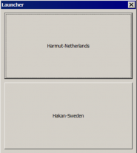  
You should see Hakefjord-Sweden and Hartmut-Netherlands to select. Try one of them. Don't close the command prompt or the nmea file will stop running. Now go setup Opencpn > Options > Connections as in item #10 above.  
  
OpenCPN Connections should have a NET Connection for:

**Type:** Net **Dataport:** 127.0.0.1 2947 .033 **Parameters:** UDP **Connection:** In/out **Filters:** none

### VDRServer1.py

==========================================  
  
  
import socket

import sys

import time

if len(sys.argv) < 4:

print(“USAGE:”)

print(”[python] VDRServer1.py InputFile IP_Address Port# [Sleep time]“)

print(“Sleep time is the delay in seconds between UDP messages sent.”)

print(“Sleep time defaults to 0.1 seconds”)

sys.exit()

UDP_IP = sys.argv[2]

UDP_PORT = int(sys.argv[3])

filename = sys.argv[1]

if len(sys.argv) > 4:

delay = float(sys.argv[4])

else:

delay = 0.1

print(['UDP target IP:', UDP_IP])

print(['UDP target port:', str(UDP_PORT)])

sock = socket.socket(socket.AF_INET, # Internet

socket.SOCK_DGRAM) # UDP

f = open(filename, 'r')

while True :

mess = f.readline()

if len(mess) < 1:

f.close()

sys.exit()

# print(mess)

mess = mess.strip()

sock.sendto(mess.encode(“utf-8”),(UDP_IP, UDP_PORT))

time.sleep(delay)